**Assignment-based Subjective Questions**

1. From your analysis of the categorical variables from the dataset, what could you infer about their effect on the dependent variable?

**Ans:** Categorical variables and their effect on dependent variables

1. **Season**

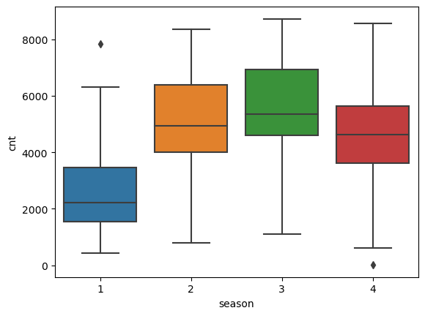

We could see that bike rentals increase up to season 3 and drop for season 4. Hence we say that ‘Season’ is good predictor